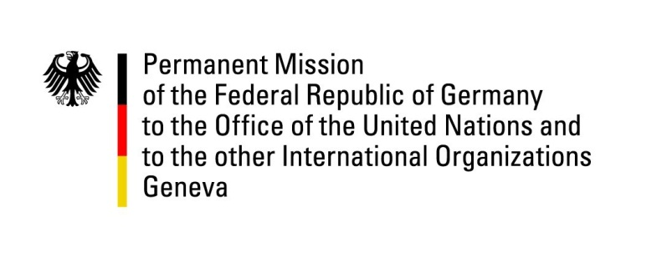

United Nations Human Rights Council
19th Session of the UPR Working Group

Geneva, 01.05.2014
---
German questions and recommendations to
The Democratic People’s Republic of North Korea

German National Statement

Mr. President,

Germany welcomes the Delegation from the DPRK to Geneva and commends its participation in the UPR-process. We sincerely hope that the recommendations offered by other states will be considered seriously as a means to improve the human rights situation in the country and allow the people of the DPRK to live a life in peace and dignity.
Germany remains deeply concerned about a wide variety of issues and, due to time constraints, would like to offer the following 5 recommendations:

- To immediately bring to an end the practice of public executions and to declare and implement an immediate moratorium on the imposition and execution of the death penalty, followed by concrete steps towards the complete abolition of the death penalty.
- To immediately end reprisals against persons on the basis of so-called “guilt by association”, especially to end the collective punishment of families of convicted criminals.
- To immediately dismantle all political prison camps and to immediately abolish the practice of forced labour.
- To heed the calls of the Commission of Inquiry on the Human Rights Situation in the DPRK and Human Rights Council Resolution 25/25 to end human rights violations, in particular human rights violations that amount to crimes against humanity, and bring perpetrators to justice.
- To undertake profound legal reforms in accordance with international law. To legalize and support free market activities that provide citizens with a livelihood and to release all prisoners detained for exercising private economic activities.

Thank you, Mr. President.

