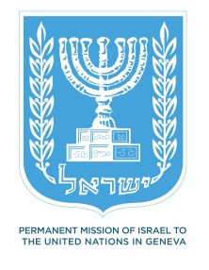
Statement on behalf of the State of Israel
UN Human Rights Council
UPR WORKING GROUP 19th SESSION
Côte d’Ivoire
Thank you, Mr. President.
Israel would like to warmly welcome the delegation of Côte d’Ivoire in its second Universal Periodic Review. The State of Israel appreciates the progress that has been achieved in Côte d’Ivoire since its first UPR in 2009, recognizing it has been against a difficult background.
Particularly, Israel congratulates Côte d’Ivoire on its valuable efforts in reconstructing the country following the civil war, the re-building of State institutions and for adopting a guidance paper on Ministry of Justice policy.
Regarding the rights of women, Israel notes that while the CEDAW forms an integral part of the country's domestic law, it has not been given sufficient visibility as a legal basis for measures related to eliminating discrimination against women. In this regard, we wish to recommend that the Convention be fully implemented. Israel recommends as well, that the country develops a comprehensive policy aimed at strengthening the judicial system, focusing on the effective access to justice for women.
Additionally, and in line with observations made by the CERD, the High Commissioner of Human Rights and the Security Council, the State of Israel wishes to recommend the Côte d’Ivoire Government to ensure that all those responsible for serious human rights abuses and violations of international humanitarian law are brought to justice in accordance with its international obligations.
Thank you.

