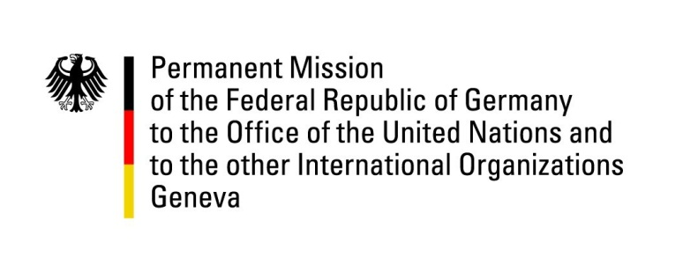

United Nations Human Rights Council
19th Session of the UPR Working Group

Geneva, 29.04.2014
---
German questions and recommendations to
Côte d’Ivoire

German National Statement

Mr. President,
Germany warmly welcomes the delegation of Côte d’Ivoire and thanks the delegation for the comprehensive presentation today. Germany commends Cote d’Ivoire for the progress made since the first UPR cycle. In particular, we welcome further stabilizing efforts that have contributed to an improvement of the general human rights situation on the ground.
Germany wishes to offer the following recommendations to the delegation of Cote d’Ivoire:
- To refrain from arbitrary arrests and to make every effort to bring detainees before a judge within the statutory deadline of 48 hours;

- To take effective action to protect women and children from sexual violence, including by strengthening and implementing legislation against domestic violence and providing counselling services and safe places for victims.

Thank you, Mr. President.

Questions submitted in advance:

- With presidential elections scheduled for 2015, what preparatory measures is Côte d’Ivoire taking to ensure elections will be conducted in a free, fair and transparent manner and in respect of every citizen’s right to participation? Is the state taking steps to reform the Independent Electoral Commission and when would such a reform be implemented? Which measures have been or will be undertaken to ensure the electoral list is up to date?

- Regarding judicial investigations into post-election violence, when are the trials for defendants held in pretrial detention expected to begin? With respect to the defendants accused of crimes in connection with the violent unrest of 2010/2011, that were released from pretrial detention last year, is the state still planning to put them on trial? What steps does Côte d’Ivoire intend to take to ensure that all perpetrators of crimes during that period are adequately prosecuted?

- During the first UPR cycle, Côte d’Ivoire accepted the recommendation to implement the country’s law on rural land tenure. What have been the main obstacles in this regard and how is Côte d’Ivoire planning to overcome them? Does the state intend to contribute to the resolution of land disputes by supporting local structures and by providing assistance to internally displaced persons who are unable to access their land?

