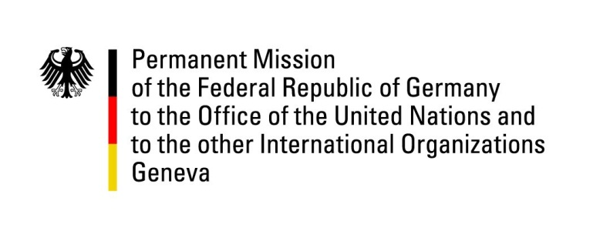

United Nations Human Rights Council
19th Session of the UPR Working Group

Geneva, 28.04.2014
---
German questions and recommendations to
Albania
German National Statement
by
H.E. Mr. Hanns H. Schumacher
Permanent Representative of the Federal Republic of Germany

Mr. President,
Germany warmly welcomes the delegation of Albania to the 2nd cycle of the UPR and commends the government for the significant progress achieved since 2009. (We particularly welcome the ratification of the UN Convention on the Rights of Persons with disabilities (2013), the establishment of the Commissioner for Protection and Discrimination as well as the National Strategy on Gender Equality.
Nonetheless, Germany remains concerned about persisting discrepancies between theory and practice. Despite reforms, the implementation of human rights has remained sketchy and fragmented.
Germany would be interested to learn about steps the government has taken to counter the phenomenon of blood feud: How does the government protect potential victims? And on what basis are related crimes investigated and prosecuted?
Germany would like to offer the following recommendations to Albania:
- To fully implement the law on “Protection from Discrimination” and to launch a national awareness campaign on the issue of discrimination and racism.
- To promote and strengthen child protection mechanisms, especially in rural areas, and to ensure equal access to education for all children with a particular focus on children from marginalized groups and minorities.
- To prevent all cases of torture and ill-treatment by police, law enforcement officials and in places of detention and to ensure effective, rapid, in-depth, independent and impartial investigations in all cases.
Thank you, Mr. President.

Questions submitted in advance:
1. Albania is still a significant country of origin and transit for trafficking in human beings, both for sexual exploitation of women and girls and forced labour. While Germany welcomes Albania’s efforts to combat trafficking in human beings, more needs to be done. Which measures has Albania adopted to enhance the protection of victims of trafficking?
2. Access to housing, in particular to vulnerable groups and individuals, remains of concern. What measures has the government taken to ensure that vulnerable groups and individuals have access to social housing, without discrimination and according to transparent, fair and expeditious procedures? And in cases where social housing is lacking, how does the government ensure that the most vulnerable families and individuals are nonetheless given priority in access to adequate and affordable accommodation?
3. Freedom of the press is an essential democratic requirement, allowing for an informed public debate. An independent media regulatory authority and a strong and independent public-service broadcasting are therefore of great importance. How does the government assess and guarantee the freedom and independence of the press in Albania? And what measures have been taken to strengthen the public-service broadcasting in the country?
4. Reports of domestic violence against women have increased in recent years, while investigative and criminal proceedings remained weak. What has the government done to overall improve investigation in and prosecution of domestic violence? And how are victims of domestic violence protected?

