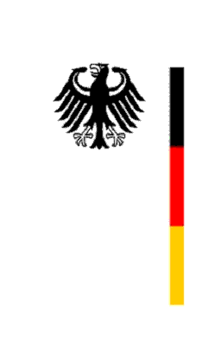

United Nations Human Rights Council
17th Session of the UPR Working Group

Geneva, 23 October 2013
---
German questions and recommendations to
Mauritius

by

H.E. Ambassador Hanns H. Schumacher
Permanent Representative of the Federal Republic of Germany
to the United Nations

Mr. President,
in the national report submitted by Mauritius, the government announced the preparation of a National Child Protection Strategy with a view to consolidating and strengthening on-going efforts and measures to respond to child protection issues and to ensuring protection of children from any forms of abuse and violence. Furthermore announced is a Children’s Bill with the aim to consolidate the various pieces of legislation on children’s rights and to harmonize all laws in line with the Convention on the Rights of the Child.
In the planned framework, what concrete measures will be taken to ensure the effective implementation of all human rights for children with disabilities, in particular with regard to effective monitoring of and protection from abuse, to the realization of an inclusive school system, as well as to the realization of accessibility and inclusiveness in society overall?
Further issues in the national report touch upon domestic violence, women’s rights, law enforcement/police complaints as well as on the situation in prisons. Mauritius has prepared a number of strategies on various issues during the reporting period (among others: Protection of Human Rights Act 2012, Police Complaints Act 2012, National Preventive Mechanism Act 2012, Criminal Code (Amendment) Act 2012); as a consequence, the main concern is now on implementation of these strategies.
How does Mauritius strengthen implementation mechanisms of strategies concerning various human rights?
Recommendation:
Germany recommends Mauritius to formally abolish the death penalty by ratifying OP2 of the ICCPR and to support the next General Assembly resolution calling for a moratorium on the death penalty.

Thank you Mr. President.

