a
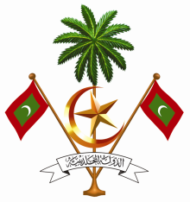
Permanent Mission of the Republic of Maldives
to the United Nations Office at Geneva

17th Session of Universal Periodic Review Working Group
Geneva, 21 October – 01 November 2013

Review of Malaysia
24 October 2013

Statement by Ms. Rishfa Rasheed, First Secretary
Permanent Mission of Maldives to the United Nations Offices in Geneva

Check Against Delivery

Thank you Madame President.

The Maldives would like to welcome the distinguished delegation of Malaysia to the Working Group on the UPR.

My delegation would like to make the following recommendations:

First, to ratify the ICCPR, ICESCR, and the Convention against Torture
Second, to accede to the two optional protocol on CRC as well as to sign and ratify the third optional protocol to CRC on communications procedure.

Finally, to continue its efforts to strengthen the enforcement of law on violence against women, and protect the rights of women.

Madame President

The Maldives welcomes the adoption of a number of important legislations by Malaysia aimed at the promotion and protection of human rights since its first review in 2009, such as the removal of a number of reservations from the CRC in 2010.

The Maldives also welcomes the amendments to the Domestic Violence Act in 2012, which have expanded the definition of “domestic violence” to include psychological and emotional injuries. The Maldives, however, is concerned by the alleged claims that there have been efforts to reclassify FGM as a medical practice. The Maldives encourages Malaysia to investigate these claims and draft appropriate legislation to address the issue of Female Genital Mutilation (FGM).
We wish the delegation of Malaysia all the success in its review.
I thank You Madame President.

