REPUBLIC OF RWANDA
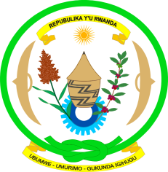
EMBASSY OF RWANDA
GENEVA

Human Rights Council Working Group on the Universal Periodic Review
Second cycle: 14th session / ZAMBIA
Geneva, 22/10-5/11/2012

Statement by the delegation of Rwanda

Mme President,

The delegation of Rwanda would like to welcome the delegation of Zambia and and thank them for their national report and continued engagement in the UPR process.

We commend the Government of the Republic of Zambia for its active engagement in the field of human rights on the regional and international levels.

Rwanda delegation commend the Government of the Republic of Zambia for several human rights achievements since the last review, including the adoption by the Parliament of the Anti-Gender Based Violence Act in 2011, and the census of population, aimed to assist the Government of Zambia to effectively plan for the realisation of economic and social rights of the people of
development programs targeting socio-economic transformation.

We recognize the ongoing process to draft a new Constitution that would meet the wishes and aspirations of the Zambian people in various human rights areas, such as freedom from torture and freedom of conscience and religion.

Being aware of the positive steps and achievements since the previous review in normative framework for human rights, the delegation of Rwanda would like to recommend Zambia to consider the ratification of the following international instruments:
- The 2nd Optional protocol to the International Covenant on civil and political rights aiming at the abolition of the death penalty
- The Optional Protocol of the Convention on Economic, Social and Cultural Rights,
- The Optional Protocol to the Convention on the Elimination of All forms of Discrimination against Women, thus eventually allowing victims access to the complaint mechanisms of the Protocol.

I thank you.

