REPUBLIC OF RWANDA
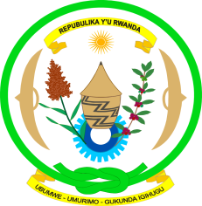
PERMANENT MISSION OF RWANDA
GENEVA

Human Rights Council Working Group on the Universal Periodic Review
Second cycle: 14th session / REPUBLIC OF KOREA
Geneva, 22/10-5/11/2012

Statement by the delegation of Rwanda

Mme President,

The delegation of Rwanda welcomes the distinguished delegation of the Republic of Korea and its valuable participation in the HRC mechanisms including the UPR process.

We commend the Government of the Republic of Korea for the wide consultation with ministries, government agencies and civil organisations during the preparation of the presented national report.

Rwandan delegation notes with satisfaction the impressive and significant efforts registered in the implementation of recommendations of the previous review.

In this regard, we welcome the enactment of Framework Act on International Development Cooperation to ensure better effectiveness and efficiency of the official development assistance.
We further note that this Framework Act on International development recognizes the promotion of human rights of women and children, fulfilment of gender equality and promotion of humanitarianism as the fundamental principles of the official development Assistance.

Being aware of all positive achievements in developing the legislations and institutions since the first UPR, my delegation would like to recommend the Republic of Korea to consider the ratification of the following international instruments:

- Convention on the Protection of the Rights of All Migrant Workers and Members of Their Families;

- The 2nd Optional protocol to the International Covenant on civil and political rights aiming at the abolition of the death penalty

I thank you.

