REPUBLIC OF RWANDA
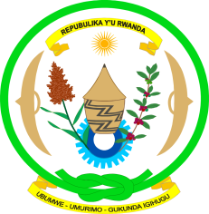
EMBASSY OF RWANDA
GENEVA

Human Rights Council Working Group on the Universal Periodic Review
Second cycle: 14th session / GUATEMALA
Geneva, 22/10-5/11/2012

Statement by the delegation of Rwanda

Mme President,

On behalf of the delegation of Rwanda, allow me to welcome the delegation of Guatemala to this UPR process, and to commend them for the comprehensive presentation of the national report.

Rwanda commends the commitment of Guatemala to following up and implementation the previous UPR recommendations in the field of human rights.

The delegation of Rwanda pays tribute to the Government of Guatemala for numerous achievements made in the field of human rights.

We acknowledge with satisfaction, the efforts of Guatemala in strengthening the institutional system through decentralization process and various socio-economic and cultural measures taken by the Government in order to uplift lives of their people in all aspects including the improvement of their rights.

Like all countries, Guatemala still faces some challenges to the full enjoyment of all human rights.

While welcoming the progress made by Guatemala and in constructive manner, Rwanda would like to recommend to:
- Adopt an overall policy and strategy and take action to eliminate gender stereotypes, gaps and all forms of discrimination that women still face.

- Consider the accession to the Second Optional Protocol to the International Covenant on Civil and Political Rights, aiming at the abolition of the death penalty.

I thank you.

