REPUBLIC OF RWANDA
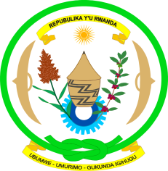
EMBASSY OF RWANDA
GENEVA

Human Rights Council Working Group on the Universal Periodic Review
Second cycle: 14th session / GHANA
Geneva, 22/10-5/11/2012

Statement by the delegation of Rwanda
(Mr. Alphonse KAYITAYIRE, 1st Counsellor)

Mme President,

The delegation of Rwanda welcomes the distinguished delegation of the Republic of Ghana.

Rwanda delegation notes the commitment of the Ghanaian Government to the principle for equal participation of men and women by adopting an Affirmative Action Policy that requires 40% representation of women in all government entities.

My delegation commends the significant progress achieved by Ghana in various human rights areas, such as access to justice, fighting against gender-based and domestic violence and combating harmful traditional practices.

We further note with satisfaction that the Government of Ghana embarked on a land administration project with objective to streamline the fair land administration and management, to stimulate economic development and to reduce poverty.

While welcoming the progress made by Ghana in implementation of the recommendations formulated in the previous UPR process, the delegation of Rwanda recommends to the Government of Ghana to consider the ratification of:

- the Convention on the rights of persons with disabilities,
- the 2nd Optional protocol to the International Covenant on civil and political rights aiming at the abolition of the death penalty,
- the Optional Protocol to the Convention on the Rights of the Child on the Sale of Children, Child Prostitution and Child Pornography.

In conclusion, Mme President, we wish Ghana all the best in all her future endeavours.

I thank you.

