Check against delivery

REPUBLIC OF RWANDA
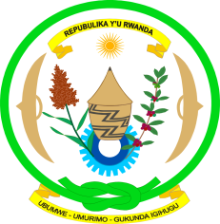
EMBASSY OF RWANDA
GENEVA

Human Rights Council Working Group on the Universal Periodic Review
Second cycle: 14th session / Gabon
Geneva, 22/10-5/11/2012

Statement by H.E Mrs Soline Nyirahabimana,
Ambassador, Permanent Representative of Rwanda

Mme President,

1. My delegation would like to begin by extending a very warm welcome to the distinguished delegation of the Republic Gabon and thank them for their presentation.

2. Rwanda’s delegation feels that it is appropriate to commend the wide range of consultations held in preparation for the UPR.

3. My delegation commends the Government of the Republic of Gabon for its substantial progress in different areas of human rights such as abolition of death penalty, promotion of access to education while raising the school attendance rate and the creation of national Human rights commission.

4. While recognising efforts made in improving women rights such as access to health care, education and senior positions in the public administration and private sector, Rwanda’s delegation recommends to Gabon, in addition to speed up the amendement of the criminal code to punish sexual violence, to adopt a comprehensive law on gender based violence and especially eradicate all forms of violence and discrimination against women and girls.

5. To conclude, Mme President, my delegation encourages Gabon to continue its positive effort in transilating the UPR recommendations into action and wishes her in her well future endevours.

I thank you.

